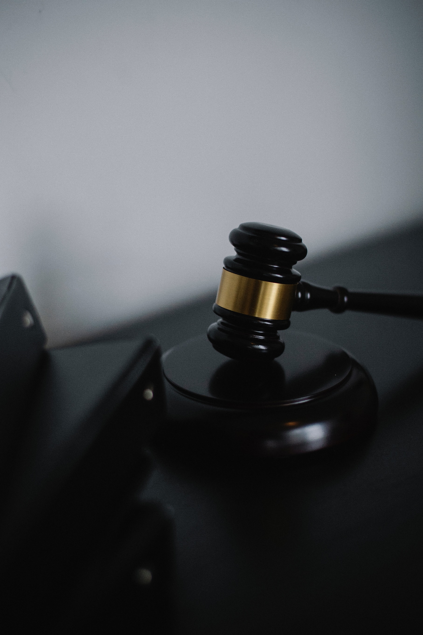LAWYER WEBSITE

“LAW NETWORK”

**PROJECT:** Lawyer Website

**Group Members:-**

|  |  |
| --- | --- |
| **GROUP MEMBERS** | **ENROLMENT NO.** |
| Asma Atique | STUDENT1353632 |
| Mahnoor Trariq | STUDENT1349179 |

**FACULTY :** HAFSA KHAN

**BATCH CODE :** 2111G2

**CURRICULUM :** 7062

**SEMESTER :** DSIM



**Table of Contents: -**

1. Acknowledgment....................................................................................................... 4
2. Declaration…………………………………………………………………………………………………………… 4
3. Certificate…………………………………………………………………………………………………………….. 5
4. **CHAPTER 1 :** INTRODUCTION…………………………………………………………………………………. 7
5. Problem Statement………………………………………………………………………………… 7
6. Need of Project……………………………………………………………………………………… 9
7. **CHAPTER 2** : PROJECT MAKING & BACKGROUNDS………………………………………………. 10
8. Project Duration………………………………………………………………………………………. 11
9. Task Sheet……………………………………………………………………………………………….. 12
10. **CHAPTER 3** : SOFTWARE & HARDWARE REQUIREMENTS…………………………………… 13
11. Hardware Requirements……………………………………………………………………………. 14
12. Software Requirements……………………………………………………………………………… 14
13. **CHAPTER 4** : WORKFLOW SUBMISSION CHECKLIST…………………………………………..… 15
14. Workflow Submission Checklist……………………………………………………………………... 16
15. **CHAPTER 5** : Screenshots……………………………………………………………………………………… 17
16. **CHAPTER V**: CONCLUSION………………………………………………………………………………….. 28
17. Remarks………………………………………………………………………………………………………… 29
18. Problem Faced……………………………………………………………………………………………… 29
19. Future Enhancement……………………………………………………………………………………… 29

- Acknowledgement:

We would want to appreciate and thank all of those people who helped us during this journey of completing our project. Without everyone’s support, we could not have accomplished our work.

We express our sincere gratitude to our faculty “--Miss Hafsa Khan--" and our coordinator for their amazing support and guidance, continuous encouragement and supervision throughout the course of the present work. It’s of no doubt that we have been very fortunate to work under such a supportive and cooperative teacher/coordinator

And last but not the least we are extremely grateful to the whole faculty and administration of Aptech, for providing us all the facilities that were mandatory, without which this project could not be a success.

2- Declaration

We are writing this to declare that all the work which is being written bellow in this Project Report entitled “—**LAWYER WEBSITE**--” is a veritable record of our own work submitted to the Aptech NN, Karachi, Pakistan during the year 2022 in the partial fulfillment of second semester (DISM) project We also declare that we have not submitted the material being presented in this Project Report for the award of any other degree elsewhere.

Signatures:

ASMA ATIQUE STUDENT 1353632

MAHNOOR TARIQ STUDENT 1379179

Certificate: -

This is to certify that,

Ms.

**ASMA ATIQUE**

**MAHNOOR TARIQ**

Has successfully Designed & Developed

**LAWYER WEBSITE**

Date of Issue:

**1th-NOV-2022**

Date of Submission:

**1th-DEC-2022**

Authorized Signature: **Miss Hafsa Khan**

 CHAPTER : 01

INTRODUCTION

Problem Statement: -

#### **LAWYER WEBSITE: -**

Today everyone need legal services for some or the other reason. It is very difficult to find lawyers with respective specialization. Getting appointment is also very difficult. There is a need to have a website for doing all this.

We need to design and develop a website for lawyers and their service. Customers can register and search for lawyers basing their requirement. Info related to lawyers will be there in website which customers can browse through and view their profile before contacting them.

Customers can book a schedule for meeting with lawyer. We also had a discussion in regard to few clarifications and inputs specifically to understand the project flow.

Web site should also record the complete information regarding the client.

**Feature:**

The user should be able to do the following:

1. Search by lawyer location, lawyer services like criminal, divorce, affidavit, civil, and then schedule a meeting with the same.
2. A customer search will show minimal info of a lawyer related to the service which customer searches, a click on lawyer profile should go to lawyer profile, where in customer can schedule a meeting and book a slot.
3. Showcase of the lawyer when they search one by one.
4. While Booking the appointment the user should input the following information:
   * Name
   * Address
   * E-mail
   * Work Phone No.
   * Cell No.
   * Date Of Birth
   * Category
   * Remarks(other additional informational)

Administrator should be able to do the following:

1. Add/Delete lawyer and appointment into the website.

1. Update the information for the existing appointment.
2. Maintenance of the web site
3. Add / Delete records in database.
4. Backup the database.
5. Generate/View the report upon top 10 best-top Lawyer.

Need of Project: -

* Customer / Lawyer registration
* Panel for lawyers
* Search by lawyer location, lawyer services like Criminal, divorce, affidavit, civil, and then meeting place
* View Lawyer profile / Book Appointment
* Login through normal registration form for customer is mandatory and for a lawyer registration form is required. Basically user/password required
* Showcase of the lawyer when they search one by one

Admin Pages

 CHAPTER : 02

PROJECT MAKING AND

BACKGROUND

PROJECT DURATION: -

* Analysis- 1 days
* Design – 10 days
* Development –15 days
* Testing – 2 days
* Documentation -2 days

|  |  |  |  |  |
| --- | --- | --- | --- | --- |
| Analysis | Design | Database | Testing | Documentation |

|  |  |  |  |  |  |  |  |  |  |  |  |  |  |  |  |  |  |  |  |  |  |  |  |  |  |  |  |  |  |
| --- | --- | --- | --- | --- | --- | --- | --- | --- | --- | --- | --- | --- | --- | --- | --- | --- | --- | --- | --- | --- | --- | --- | --- | --- | --- | --- | --- | --- | --- |
| 1 | 2 | 3 | 4 | 5 | 6 | 7 | 8 | 9 | 10 | 11 | 12 | 13 | 14 | 15 | 16 | 17 | 18 | 19 | 20 | 21 | 22 | 23 | 24 | 25 | 26 | 27 | 28 | 29 | 30 |

TASK SHEET

|  |  |  |  |  |  |
| --- | --- | --- | --- | --- | --- |
| **No.** | **Task** | **Actual Start Date** | **Actual Days** | **Team Mate Name** | **Status** |
| 1. | Case Study | 11th NOV  2022 | 2 | ASMA ATIQUE  MAHNOOR TARIQ | Completed |
| 2. | UI Designing | 21th NOV 2022 | 9 | ASMA ATIQUE  MAHNOOR TARIQ | Completed |
| 3. | SCENARIO Making | 21th NOV 2022 | 8 | ASMA ATIQUE  MAHNOOR TARIQ | Completed |
| 4. | Material Searching | 25ST NOV 2022 | 3 | ASMA ATIQUE    HAMZA AHMAD SIDDIQUI | Completed |
| 5. | Database Connectivity | 25th NOV  2022 | 6 | ASMA ATIQUE MAHNOOR TARIQ | Completed |
| 6. | Documentation | 1th DEC 2022 | 2 | ASMA ATIQUE | Completed |



CHAPTER : 03

SOFTWARE REQUIREMENTS

SOFTWARE REQUIREMENTS: -

* Visual Studio Code
* XAMPP
* Browser Google



CHAPTER : 04

SOFTWARE REQUIREMENTS

WORKFLOW SUBMISSION CHECKLIST:-

|  |  |  |  |
| --- | --- | --- | --- |
| **S.NO** | **LIST OF ITEMS** | **Remarks** | **COMMENTS** |
| 1. | Do All Pages  Linked together | **Yes** | Through the URL.. |
| 2. | Database Connected | **Yes** | Using  mySQL |
| 3. | Page Colors As Per Common Guidelines | **Yes** | Professional Color Combination |
| 4. | All Tables  Working | **Yes** | CRUD Operations Done |
| 5. | DOCUMENTATION Included | **Yes** | All 3 word documents. |
| 6. | Project Zip File | **Yes** | Created using WinRAR |



CHAPTER : 05

SCREEN SHOOT

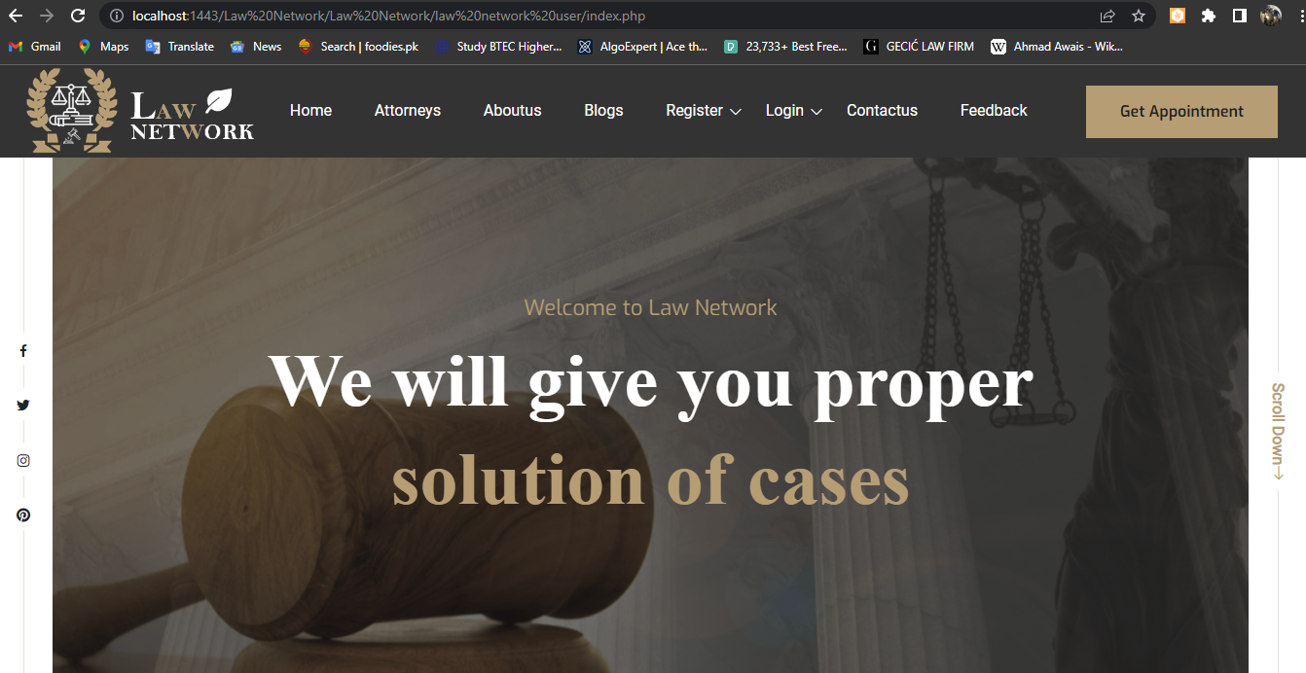

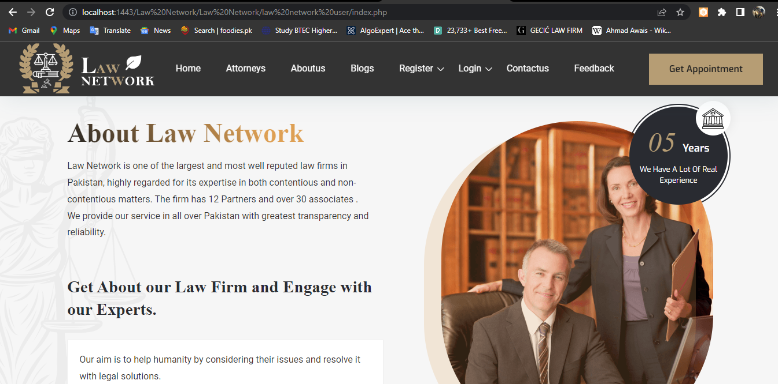

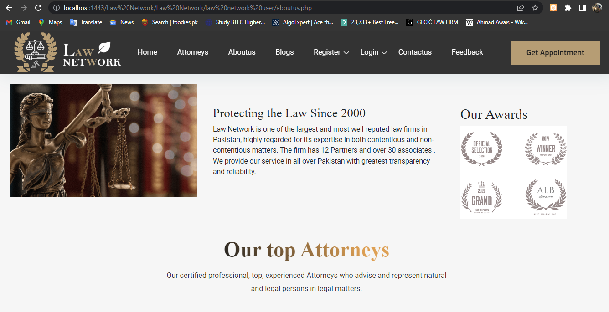

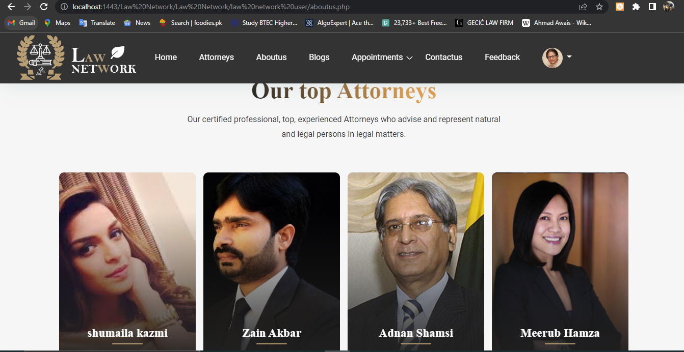

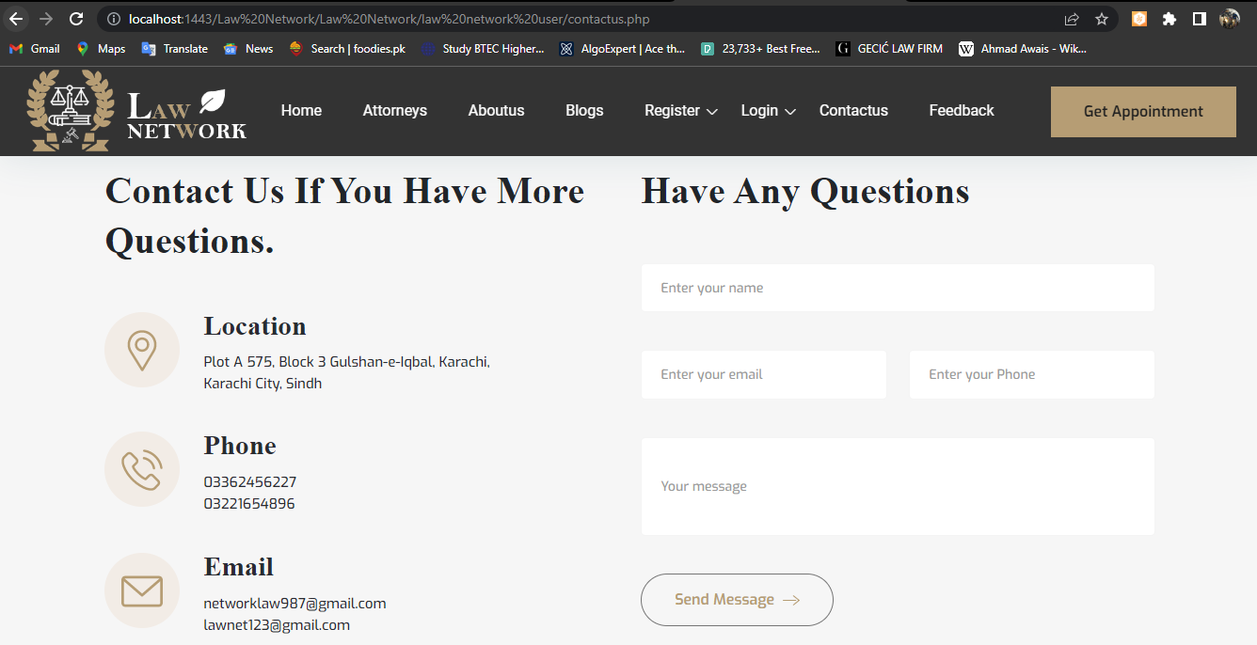

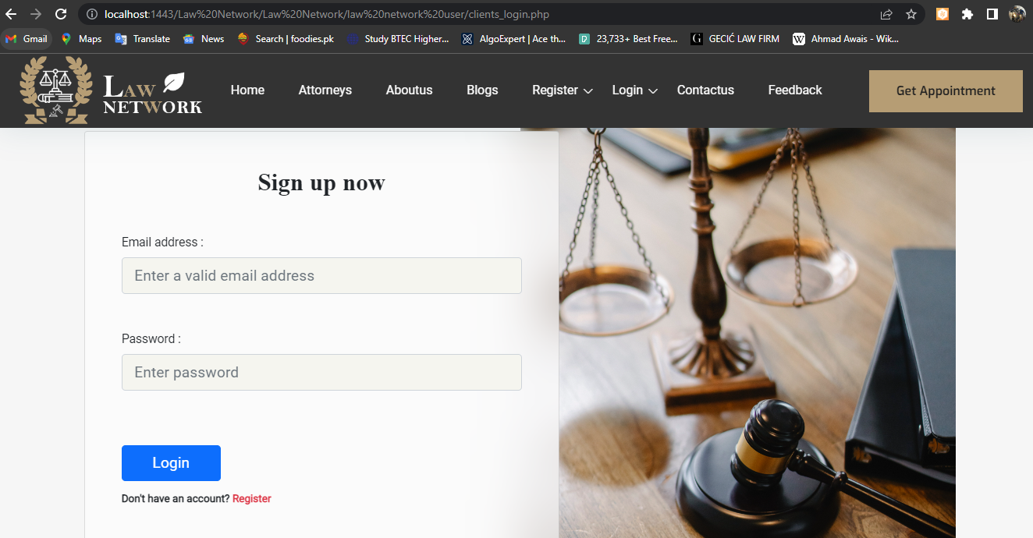

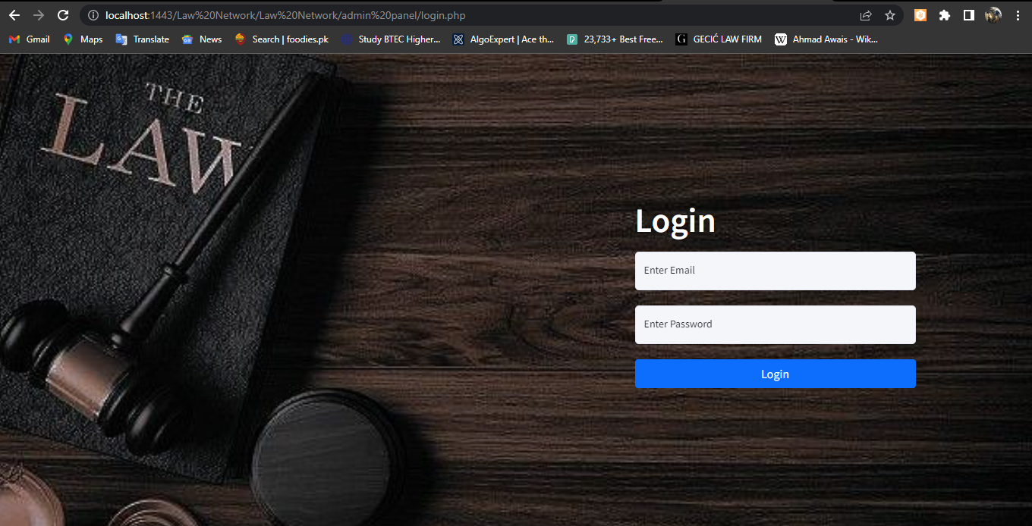

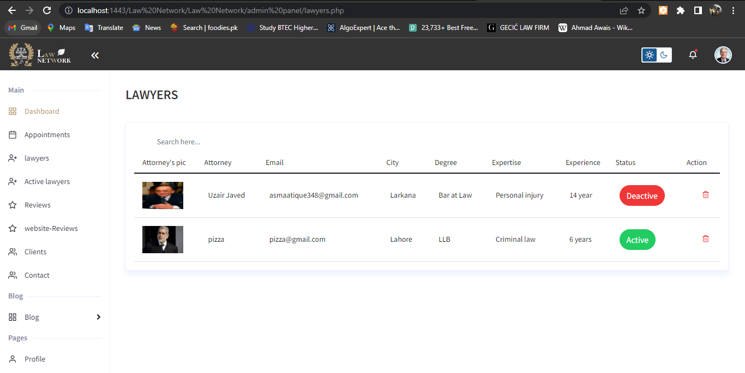

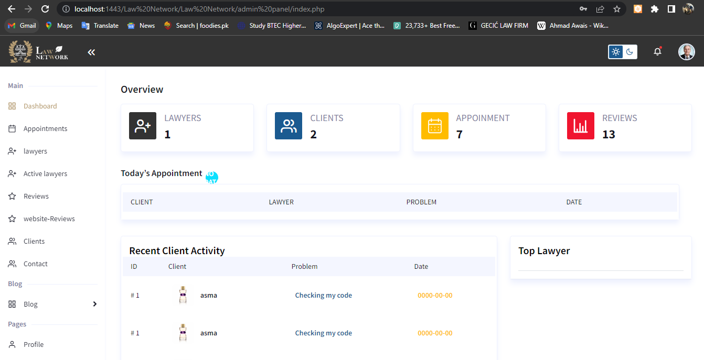

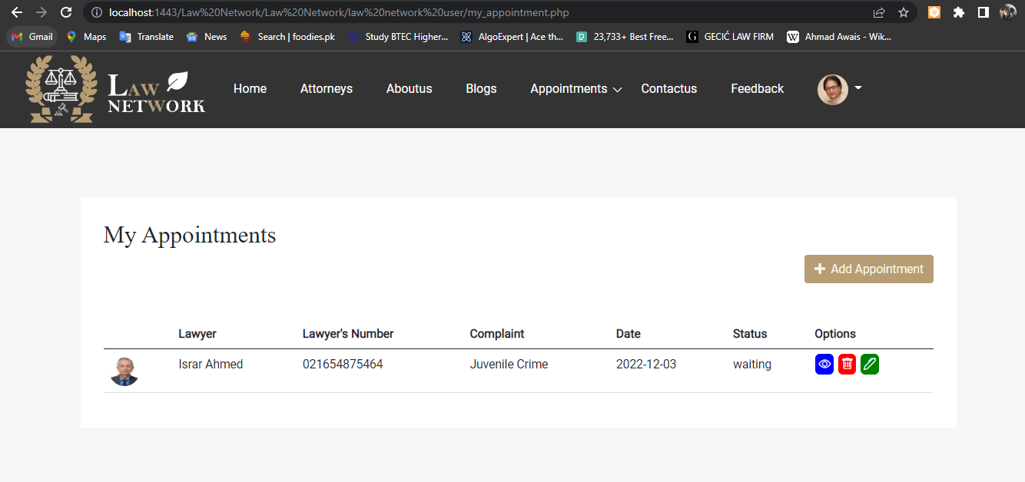



CHAPTER : 07

CONCULSION

Remarks: -

It is very nice initiative that has made us work harder on our project and it has polished our skills now. We are capable of making a Website by own self. We are very thankful to you.

Future Enhancement: -

It is almost a perfect prototype of LAWYER WEBSITESystem. This Websites can be deployed and used in real world! But there is always a place for betterment so ere are our few suggestions, Enclosures will be added soon. Also interaction with our regular customers can be maintained using mail, message etc.